Print bed assembly

Vitamins
1 PCB bed mk42  4 M3 cap screw x 10mm  4 Hex male / female pillar M3 x 20mm  1 Polypropylene strip 271mm x 33mm x 0.5mm  1 Ribbon cable 26 way 381mm | 2 Heatshrink sleeving ID 1.6mm x 15mm  2 Heatshrink sleeving ID 2.4mm x 15mm  2 Heatshrink sleeving ID 6.4mm x 30mm  4 Washer M3 x 7mm x 0.5mm  1 Black wire 32/0.2 length 635mm  1 Red wire 32/0.2 length 620mm

Sub-assemblies
1 y_carriage_assembly
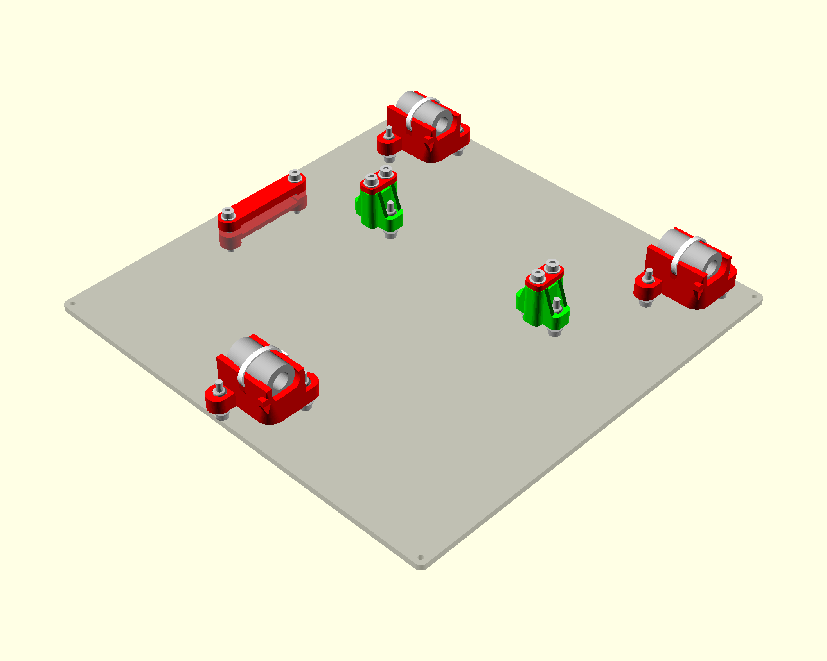

Bed Wiring

- Separate all the 26 ways of the ribbon cable and strip about 10mm of insulation.
- Twist the first 12 wires together, leave two for the thermistor and then twist the last 12 together. It is easier to twist bunches of three together and then twist four of those bunches to get all 12 to meet. Alternatively roll the twelve wires into a tube before twisting.
- Apply solder to tin the twisted ends.
- Solder the two groups of 12 wires to the PCB so that they lead off towards the middle, as shown below. Be careful not to get solder down the holes in the PCB as that will prevent the glass from lying flat. Ensure the red wire is the one on the right.
- Put the 1.6mm heat shrink on the middle two wires and solder them to the thermistor. Shrink the sleeving with a heat gun or place it over the soldering iron very close but not touching. TIP: use an ohm meter to verify that you got the connections right
- Use kapton tape to tape down the thermistor. Tape it down at least past the heat shrink. One strip on the bed. Then place the thermistor at the center hole. Don’t force it in but just the it rest there. Then place another strip on top. Make sure the wires are keept seperated.

- Separate, strip and bunch the other end of the cable in the same way and solder the red and black 32/0.2 wires as shown below and then sleeve with the 6.4mm heat shrink.
TO BE DONE: Is 32/0.2 the same gauge as that in a 15A mains cable?
http://circuitcalculator.com/wordpress/2007/09/20/wire-parameter-calculator/

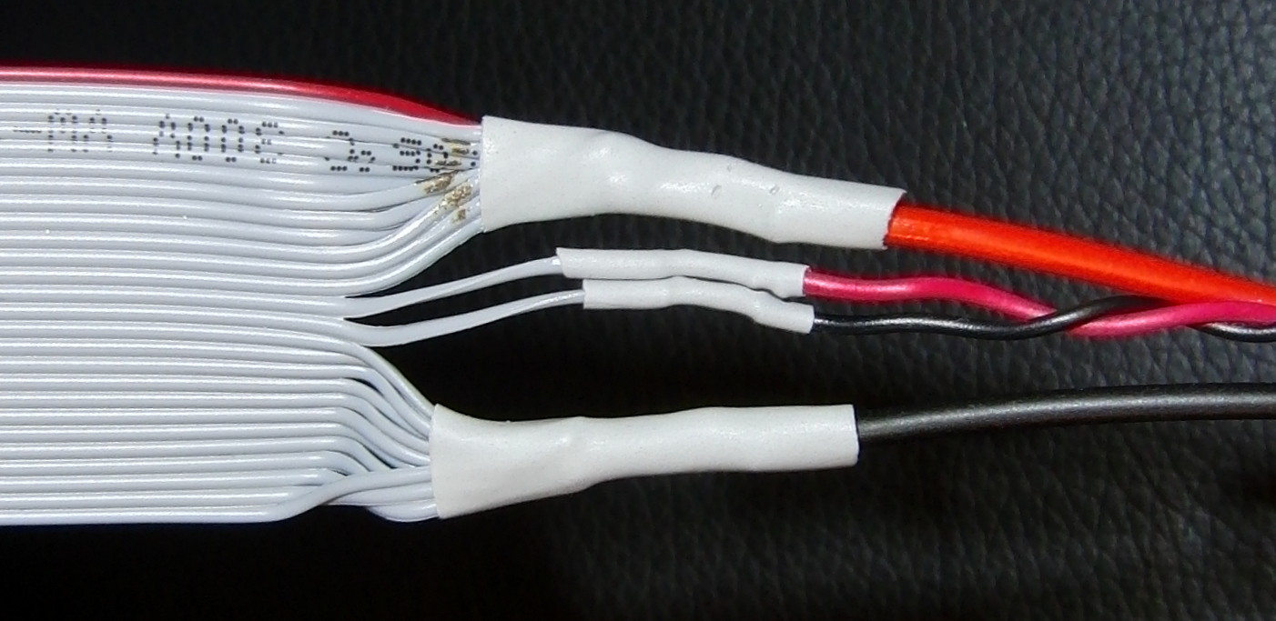
- Use red and black wires trimmed from the X motor for the thermistor wiring. Twist them before soldering and sleeve with the 2.4mm sleeving. Observe the polarity above for minimum crosstalk with the heater. Cut them 100mm longer than the black heater wire.

Assembly
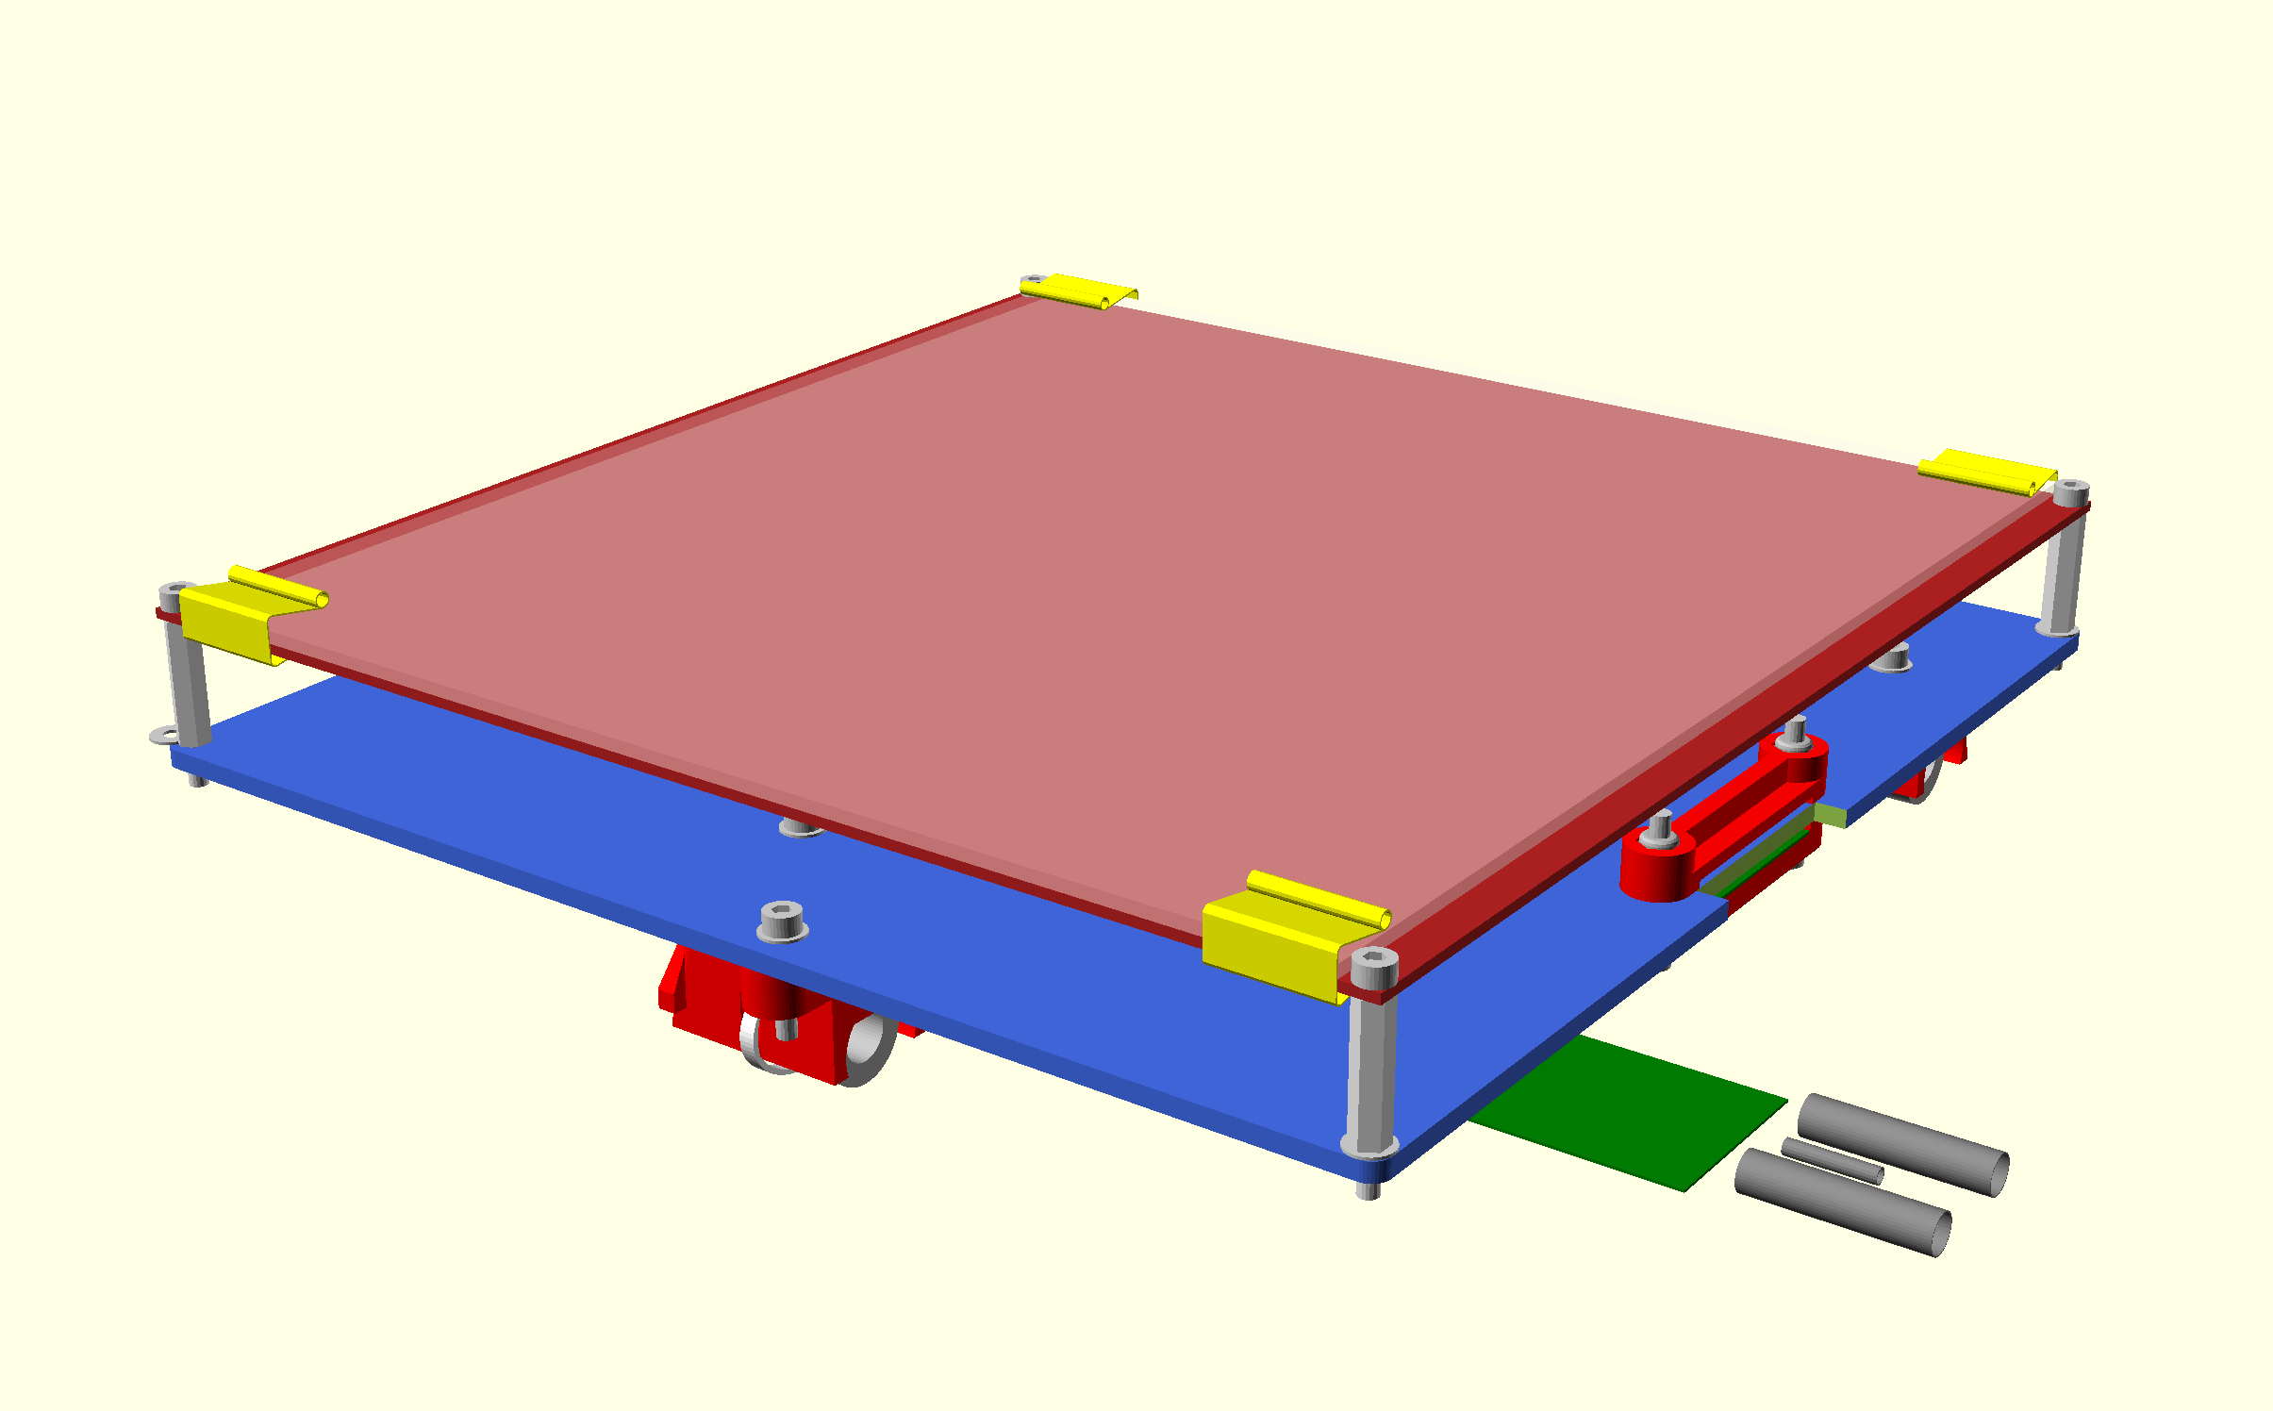
- Tap the corner holes and the 2 center holes to 3mm. Screw the pillars into the Y carriage, but don't over tighten as it is quite soft. Note that the rear two pillars have a washer under them. The front two are initially spaced the same distance by using a washer as a temporary shim. They can then be adjusted up or down slightly to level the bed relative to the nozzle.
- The bed is installed with the cable at the back. It initially leads off forwards and then loops back on itself under the top ribbon clamp. It then doubles back under the Y carriage through the lower cable clip.
- Screw the bed to the top of the pillars with the M3 x 10 cap screws (no washers). Just start the screws as you will need to take the bed off again to tighten the last bearing holder. This is best done when belt etc. are in place

TO BE DONE: DP notes says to use button head screws as they reduce height and interference with HE and then no PP strip used?

- Pull the ribbon cable tight enough so that the loop under the bed does not touch the bed and clamp it together with the polypropylene strip (which goes closest to the clamp).

